Distribution of PAHs, PCBs, and PCDD/Fs in products from the full-scale pyrolysis of diverse contaminated organic waste

*Katinka M. Krahn1, Erlend Sørmo2,3, Gudny Øyre Flatabø4, Thomas Hartnik5, Hans Peter H. Arp3,6, Gerard Cornelissen2,3\**

1) Lindum AS, 3036 Drammen, Norway

2) Norwegian University of Life Sciences (NMBU), 1430 Ås, Norway

3) Norwegian Geotechnical Institute (NGI), 0484 Oslo, Norway

4) Scanship AS, Nedre Langgate 19, 3126, Tønsberg, Norway

5) Norwegian Institute of Bioeconomy Research (NIBIO), 1433 Ås, Norway

6) Norwegian University of Science and Technology (NTNU), 7491 Trondheim, Norway

*Corresponding author contact details: gerard.cornelissen@ngi.no

### Keywords:

Pyrolysis, sewage sludge, organic waste, legacy pollutants, biochar, emission factors

### Graphical Abstract

Abstract

Emission concentrations, emission factors, total concentrations in feedstock and biochar at different temperatures are provided for PAH, PCDD/Fs and PCBs. Seven feedstocks were tested: waste timber, garden waste, limed sludge, digested sludge, food waste reject, pyrolyzed at temperatures between 500-800 ˚C in a full-scale medium size pilot unit dry pyrolysis plant, slow. Pyrolysis eliminated PCDD/F and PCBs in feedstocks, however, PAHs were formed, but below EBC guidelines some of them.

# Introduction

Persistent organic pollutants that originate from synthetic chemicals in consumer products distribute into the environment and subsequently concentrates in waste streams (Cornelissen et al., 2012; Olie et al., 1977; Pereira & Kuch, 2005). Polychlorinated biphenyls (PCBs), polychlorinated dibenzo-p-dioxins and dibenzofurans (PCDD/Fs), and polycyclic aromatic hydrocarbons (PAHs), are groups of legacy pollutants of particular concern due to their persistence, bioaccumulation, and toxicity (Eljarrat & Barceló, 2003). Their distribution into all compartments of the environment and toxic effects have been studied extensively in the past decades and show that PCBs, PCDD/Fs are ubiquitous in the environment (Gabrielsen & Henriksen, 1974; Jia et al., 2014; Paulsrud et al., 1997) and that PAHs easily form during waste incineration due to incomplete combustion (Horii et al., 2008). Therefore, there is a need to develop safe methods to treat waste that contains a diversity of organic pollutants.

PCBs are planar molecules that consist of two chlorinated benzene rings connected by a carbon-carbon bond. PCBs are well-known for their strong chemical and physical stability, resistance to degradation at high temperatures, low volatility, and electrical resistance, making them ideal for use in electrical equipment (Castro-Jiménez et al., 2008). The production and use of PCBs were banned in several countries in the 1970s and 1980s. PCBs accumulate in the fatty tissues of animals and humans and have various long-term harmful health effects, such as developmental and neurological impairments, immune suppression, and cancer.

Polychlorinated dibenzo-p-dioxins and dibenzofurans (PCDD/Fs) are a class of tricyclic aromatic compounds that are formed unintentionally during the production of chlorinated compounds or during combustion processes. These compounds have two aromatic rings with varying degrees of chlorination and a bridge formed by one or two oxygen atoms (PCDF and PCDD, respectively). PCDD/Fs are potent carcinogens and can activate the aryl hydrocarbon receptor (AhR) in cells. They are formed during waste incineration and chemical manufacturing (such as herbicides and pesticides) under specific conditions involving high temperature, organic matter, chlorine, low oxygen levels that promote incomplete combustion, and long residence times (Stanmore, 2004). PCDD/Fs are more acutely toxic than PCBs and can cause skin lesions and chloracne. They are also potent carcinogens that can cause reproductive and developmental effects. PCDD/Fs are more water soluble than PCBs due to the oxygenated ring.

Polycyclic aromatic hydrocarbons (PAHs) are a group of organic molecules made up of two or more (to six) fused aromatic rings. They are formed through the incomplete combustion of organic matter, such as fossil fuels, wood, and plastics. Some PAHs are toxic, mutagenic, and carcinogenic to humans and biota.

PCDD/Fs and PCBs up-concentrate in most waste streams such as sewage sludge and other organic waste due to their ubiquitous presence. High concentrations of organic pollutants make proper waste management challenging to safely remove/stabilize PCDD/Fs and PCBs along with the diverse suite of contaminants in the organic waste. Municipal waste incineration at >1000 ˚C is the standard waste handling strategy for dealing with hazardous contaminated waste streams. However, incineration emits greenhouse gases and is energy intensive for wet substrates such as sewage sludge. Additionally, pyrolysis of sewage sludge to produce biochar is a promising solution for the restrictions on use of raw sewage sludge on agricultural fields due to contents of organic pollutants, heavy metals, and nutrient enrichment. In many countries, direct application of sewage sludge to soil has been banned.

The EU Health and Environmental Risks and Scientific Committee on Emerging and Newly Identified Health Risks STRUBIAS report includes sewage sludge from the list of prohibited fertilizing products in the EU. STUBIAS report is hesitant about pyrolysis and gasification being a treatment method for removal of organic pollutants (Huygens et al., 2019). But largely based on hydrothermal carbonization (HTC) which is conducted at low-temperature (180-250 ˚C). Sewage sludge is also banned as feedstock to produce pyrolysis and gasification matrerials due to the lack of data on the fate of organic pollutants (Moško et al., 2021).

Several studies address the removal of persistent organic pollutants from organic waste and sewage sludge by pyrolysis in lab-scale studies (Buss, 2021; Conesa et al., 2009; Moško et al., 2021). Pyrolysis is a potentially sustainable and carbon negative way to treat sewage sludge, especially for sludges with low levels of heavy metals. During pyrolysis at high enough temperatures, organic contaminants are expected to evaporate or mineralize, ending up with a biochar product with low levels of contaminants that can be applied as soil amendment in agriculture, as sorbent or as a component in building materials. Recent work by (Sørmo et al., n.d.) released the first decomposition data and emission factors for PFAS compounds from waste fractions during pyrolysis from a full-scale pilot pyrolysis unit.

However, pyrolysis is not yet an approved method for removal of contaminants from sewage sludge.

* + Relation between temperature and PAH content, difference to leaching.(Hilber et al., 2017), describe that PAH and PCDD/F in biochar show very limited bioavailability although some may be released in the gut.

Sørmo 2020 pyreg:

The European Biochar Certificate specifies contaminant threshold

levels in biochar for agricultural soil improvement (EBC, 2012). These

threshold levels are all based on total content in the solid phase. Meanwhile,

to give an accurate assessment of risk, bioavailable concentrations

should be considered (Reichenberg and Mayer, 2006).

* + Mosko found that the removal efficiency of PAHs, PCBs and PCDD/Fs increased with increasing pyrolysis temperature, with the highest removal observed at 700 degrees. The researchers attribute this trend to increased decomposition and transformation of the organic pollutants into less toxic forms. However, high pyrolysis temperature comes at a cost of lower carbon yield

Moško et al. (2021) addressed the knowledge gap on the lack of data on the fate of organic pollutants (PAHs, PCBs, PPCPs) and heavy metals, during pyrolysis and found that…. Knowledge gap: what happens to PCDD/Fs and PCBs during pyrolysis, and how many PAHs are formed during pyrolysis of waste. Formulate hypotheses out of it. Mosko studied removal of organic pollutants and heavy metals during pyrolysis of sewage sludge in lab-scale experiments. This study does the same but in pilot scale and analyzes all pyrolysis products (exhaust, oil and biochar) for a more complete mass balance than what has been done previously for PCDD/Fs, PCBs and PAHs in waste based materials. In this study, the same waste feedstocks as in (Sørmo et al., n.d.) were studied for PCDD/Fs, PCBs and PAHs using the same pyrolysis reactor, a full-scale medium size pilot pyrolysis unit.

Compare stability of PCDD/F, PCB to that of PFAS (strength of C-F binding to C-Cl), are there some numbers on PCDD/F fate during incineration?

# Materials and methods

## Chemicals, waste feedstocks and pre-treatment

Whatman® Glass fiber filters (GFF) and 153 Amberlite® XAD-2® were acquired from Merck (Darmstadt, Germany), what about PUF?

Seven waste-derived feedstocks, and one reference material (CWC), were investigated in this study (

Table 1). The waste-derived feedstocks were four sludge-based feedstocks (DSS-1, DSS-2, and LSS), one reject from food waste for biogas production (FWR), and two wood-based feedstocks (GW and WT). Each feedstock was subsampled, dried and pelletized (length 40 mm, radius 8 mm) before pyrolysis according to the methods described in Sørmo et al., (n.d.).

Table 1. Description of the waste material feedstocks studied, conditions for their respective pyrolysis treatments, and sampling information.

|  |  |  |  |  |  |  |
| --- | --- | --- | --- | --- | --- | --- |
| **Feedstock** | **Abbrev.** | **Description** | **Pyrolysis temperatures (˚C)** | **Pyrolysis residence time (min)** | **Solid phases sampled** | **Flue gas sampled** |
| Digested sewage sludge | DSS-1 | Sewage sludge and food waste pre-treated with thermal hydrolysis (170 ˚C) followed by anaerobic digestion for biogas production | 500, 600, 700 and 750 | 20 | Yes | Yes (except 750 ˚C) |
| Digested sewage sludge | DSS-2 | Sewage sludge treated by anaerobic digestion for biogas production | 500, 600, 700 and 800 | 20 | Yes | Yes |
| Limed sewage sludge | LSS | Sewage sludge treated by anaerobic digestion for biogas production, then stabilized/hygenized by addition of lime (39%) | 600 and 700 | 20 | Yes | Yes |
| Food waste reject from biogas production | FWR | The rejected fraction of food waste before biogas production. Consists of material that does not pass the initial sieving process that removes plastics and other items that are too large or non-digestible | 600 and 800 | 20 | Yes | Yes |
| Garden waste | GW | Gardening waste from private housholds and businesses. Fraction includes twigs, leaves, roots and some sand/gravel | 500, 600 and 800 | 20 | Yes | Yes (500 and 800 ˚C) |
| Waste timber | WT | Discarded wood products and objects from private housholds, businesses and construction/demolition (no chemically impregnated wood) | 500, 600, 700 and 800 | 20 | Yes | Yes |
| Wood chips | CWC | Pellets produced from pine and spruce wood chips from forestry/logging | 500, 600, 700 and 750 | 20 | Yes | Yes |

## Pyrolysis

The feedstock pellets were pyrolyzed using a medium scale Biogreen® pyrolysis unit (2-10 kg biochar/hr) built by ETIA Ecotechnologies using the technology and operational conditions (temperatures and residence times,

Table 1) specified in Sørmo et al., (n.d.). The pyrolysis gas was channeled into a condenser unit where pyrolysis oil was collected through a liquid lock while the syngas was led further to a combustion chamber where it was combusted with propane at 800-900 ˚C before being released as exhaust through a chimney. Gas emission measurements and samples were collected from the chimney during stable temperature conditions.

## Sampling and emission measurements

### Solids sampling

Solids sampling and sample preparation (feedstock, biochar, and oil) were conducted according to the procedures described in Sørmo et al., (n.d.). Samples ready for chemical characterization consisted of feedstock pellets, dried and crushed (D < 1 mm) biochar and pyrolysis oil that was vigorously shaken to homogenize the oil and water phase. Biochar samples were characterized for all pyrolysis treatments (

Table 1). Pyrolysis oil was characterized only for CWC and DSS-1-600, 700 and 800 ˚C.

Biochar yields (Ybiochar %) at each treatment temperature were obtained from the Sørmo et al., (n.d.) study, where Ybiochar % was defined as the rate of biochar produced divided by the feedstock feeding rate over the period with stable conditions.

### Gas emission sampling

Exhaust gas and aerosols were sampled according to the procedure described in Sørmo et al., (n.d.). Gas measurements were collected for sewage sludge feedstocks, except for CWC (all treatments), DSS-1 (750 ˚C treatment), and GW (600 ˚C treatment). A glass fiber filter (GFF) was used for aerosol collection (0.45 µm), followed by an XAD-2 sorbent for gas phase contaminants from the sludge-based feedstocks, and a PUF sorbent for the wood-based feedstocks.

## Sample preparation and instrumental analysis

GFF, PUF and XAD were extracted using accelerated solvent extraction (ASE) and the extracts were analyzed by GC-MS/MS according to ISO 12884 for PAHs, PCBs, and PCDD/Fs (details in (Cornelissen et al., 2012)). Procedural blanks were taken to analyze background contamination at the pyrolysis plant. PAHs were measured in triplicate and dioxins were analyzed from single measurements. Samples were analyzed in triplicate for feedstocks and biochar, duplicate for GFF, and single measurements for XAD, PUF and pyrolysis oil.

## Data analysis

For statistical analyses, LOQ/2 was used in cases where one or two of the replicate data points were < LOQ.

Removal efficiency (RE) was calculated as previously defined by Moško et al. (2021):

|  |  |
| --- | --- |
| $$RE \left(\%\right)=100\%-\left(\frac{C_{biochar}*Y_{biochar}}{C_{feedstock}}\right)$$ | (Eq. 1) |

where Cbiochar is the pollutant concentration (ng g-1) in the biochar produced at a given pyrolysis temperature, Cfeedstock is the pollutant concentration (ng g-1) in the feedstock and Ybiochar is the yield (Eq. 1) of the biochar in the pyrolysis process. To be conservative, values below LOQ were set equal to LOQ when calculating removal efficiencies.

Emission factor (EF) was calculated using the volume gas sampled per kg biochar (m3 kg-1) that was normalized for propane added to the burner during combustion of the flue gases as described by Sørmo et al., n.d.):

|  |  |
| --- | --- |
| $$EF_{pollutant}=conc_{pollutant}*V_{flue gas}$$ | (Eq. 2) |

# Results and discussion

## Organic pollutants in feedstocks

Legacy contaminants are expected to be present in most waste streams due to their general presence in the environment. PCBs, PCDD/Fs have been found in soils in polar regions (Jia et al., 2014), water (Castro-Jiménez et al., 2008), animals (Warenik-Bany et al., 2019) , food (Törnkvist et al., 2011), and sewage sludges (Pereira & Kuch, 2005; Stevens et al., 2001). Despite PCDDS/F formation being associated with waste incineration, dioxins are unlikely to form during pyrolysis due to the high temperature and short treatment residence time (Stanmore, 2004). Thus, dioxins detected in the pyrolysis products are expected to derive from the feedstock. This initial concentration is therefore the basis for calculation of removal efficiencies and mass balances. However, waste containing high levels of chlorine is at risk of dioxin formation even during pyrolysis at high temperatures (do we get cl data for feedstocks?).

PAHs are mainly formed during incomplete combustion processes and are expected to be found in natural soil that have been influenced by volcanic activity and forest fires (Wilcke, 2000), and urban soils due to industry and road traffic (Kwon & Choi, 2014). However, the primary source of PAHs is expected to form during pyrolysis (Chen et al., 2007; Nakajima et al., 2007).

Table 2 Total concentration of PAHs, PCDD/Fs and PCBs in feedstock (F) and biochars produced at various temperatures (500-800 ˚C) and European Biochar Certificate (EBC) limit values.

|  |  |  |  |  |  |  |  |  |  |  |  |
| --- | --- | --- | --- | --- | --- | --- | --- | --- | --- | --- | --- |
| **PAHs (mg/kg)** | | | | | | **PCDD/F (ng/kg)** | | | **PCBs (µg/kg)** | | |
|  | **Temp.** | **∑16 EPA PAH** | **∑16 EPA PAH EBC limit** | **∑8 EFSA PAH** | **∑8 EFSA PAH EBC limit** | **∑17 PCDD/F (TEQ)** | **∑PCDD/F EBC limit** | **∑17 PCDD/F** | **∑7 PCB** | **∑PCB EBC limit** | **∑6 PCB EBC limit** |
| **DSS-1** | **F** | 1.48 ± 0.03 | 6 mg/kg DM | 0.52 ± 0.01 | 1 mg/kg DM  (4 mg/kg DM for EBC BasicMaterials) | 8.3 ± 0.4 | 20 ng/kg I-TEQ OMS | 2011 ± 118 | 21 | 200 µg/kg DM | 10 µg TEQ/kg DM |
| **500** | 18 ± 1 | 3.1 ± 0.09 | n.d. | 2.69 | 1.7 |
| **600** | 22 ± 1 | 1.73 ± 0.07 | n.d. | 2.01 | <LOQ |
| **700** | 7 ± 0.3 | 0.25 ± 0.01 | n.d. | 2.58 | 1.3 |
| **800** | 3.7 ± 0.1 | 0.14 ± 0.01 | n.d. | 0.44 | 0.3 |
| **DSS-2** | **F** | 0.5 ± 0.02 | 0.148 ± 0.004 | 1.78 ± 0.04 | 302 ± 6 | 7.6 ± 0.3 |
| **500** | 37 ± 2 | 2.54 ± 0.08 | 0.03 | 3.31 | 0.6 |
| **600** | 22.9 ± 0.5 | 0.83 ± 0.01 | 0.02 | 2.89 | 0.4 |
| **700** | 5.9 ± 0.5 | 0.17 ± 0.01 | 0.03 | 3.15 | 0.4 |
| **800** | 23 ± 1 | 1.02 ± 0.05 | 0.03 | 2.66 | 0.5 |
| **FWR** | **F** | 0.38 ± 0.01 | 0.08 ± 0.004 | 1.18 ± 0.05 | 323 ± 14 | 9.2 ± 0.4 |
| **600** | 9.1 ± 0.5 | 0.22 ± 0.01 | 0.1 | 9.5 | n.d. |
| **800** | 6.7 ± 0.3 | 0.2 ± 0.01 | 0.003 | 0.3 | n.d. |
| **LSS** | **F** | 0.98 ± 0.03 | 0.39 ± 0.01 | 3 ± 0.1 | 589 ± 29 | 17 ± 1 |
| **600** | 3.38 ± 0.04 | 0.15 ± 0.01 | n.d. | n.d. | 0.3 |
| **750** | 2.7 ± 0.1 | 0.13 ± 0.01 | n.d. | n.d. | 0.2 |
| **WT** | **F** | 5 ± 0.1 | 1.08 ± 0.02 |  |  |  |  |  |  |
| **500** | 2.5 ± 0.1 | 0.16 ± 0.01 |  |  |  |  |  |  |
| **600** | 118 ± 5 | 7.46 ± 0.22 |  |  |  |  |  |  |
| **700** | 21 ± 1 | 0.45 ± 0.01 |  |  |  |  |  |  |
| **800** | 5 ± 0.3 | 0.13 ± 0.01 |  |  |  |  |  |  |
| **GW** | **F** | 0.89 ± 0.02 | 0.141 ± 0.005 |  |  |  |  |  |  |
| **500** | 14 ± 1 | 0.54 ± 0.02 |  |  |  |  |  |  |
| **600** | 5 ± 0.2 | 0.31 ± 0.01 |  |  |  |  |  |  |
| **800** | 7.1 ± 0.3 | 0.25 ± 0.01 |  |  |  |  |  |  |
| **CWC** | **F** | <LOQ | <LOQ |  |  |  |  |  |  |
| **500** | 9.4 ± 2.5 | 0.39 ± 0.08 |  |  |  |  |  |  |
| **600** | 17 ± 5 | 0.56 ± 0.19 |  |  |  |  |  |  |
| **700** | 6.6 ± 3.4 | 0.23 ± 0.09 |  |  |  |  |  |  |
| **750** | 6.4 ± 0.1 | 0.26 ± 0.02 |  |  |  |  |  |  |

### PCDD/Fs in feedstock

The total concentration of dioxins (PCDD/F-17) in toxic equivalents (TEQ) in the sludge and food waste reject feedstocks were 1.2±0.1, 1.8±0.1, 3.0±0.1, and 8.3±0.2 ng TEQ kg-1 for FWR, DSS-2, LSS, and DSS-1, respectively. These concentrations were in the lowest range or below the sum PCDD/F-17 found in 36 different Norwegian sewage sludges (range 3-69, median 6 ng TEQ kg-1) (Paulsrud et al., 1997). The distribution of dioxins was similar for the sludge feedstocks and mainly dominated by OCDD (85-91%), followed by 1,2,3,4,6,7,8-HpCDD (6-11%) (Figure S.X). The distribution of dioxins in FWR was dominated by OCDD (80%), 1,2,3,4,6,7,8-HpCDD (9%), and OCDF (9%).

### PCBs in feedstocks

The total concentration of PCB-7 in the four feedstocks analyzed were 7.6 ± 0.6, 9.2 ± 0.4, 16.6 ± 1.0, and 20.7 ± 0.6 µg kg-1 for DSS-2, FWR, LSS, and DSS-1, respectively (Figure S.X). These concentrations were below previously reported findings: range in x WWTPs in x

These concentrations were below the sum PCB-7 found in 36 different Norwegian sewage sludges (range 17-100, median 42 µg kg-1) (Paulsrud et al., 1997). The distribution of PCBs was evenly distributed between the 7 PCBs in DSS1, DSS-2, and FWR, whereas LSS was dominated by PCB52 (60%).

### PAHs in feedstocks

PAHs are generally a product of combustion and was not expected to be present at high concentrations in the feedstocks. However, all 16 PAHs analyzed for were detected in the feedstocks except for in the wood chips (CWC) in concentrations ranging from 0.38 ± 0.01 mg kg-1 in food waste reject (FWR) to 5.05 ± 0.09 mg kg-1 in waste timber (WT) (Figure S.X). These concentrations are in the same range as the lower range of sum PAH-16 found in 36 different Norwegian sewage sludges (range 0.7-30, median 3.9 mg kg-1) (Paulsrud et al., 1997). Click or tap here to enter text. PAH content increased at lower pyrolysis temperatures (400 deg) and decreased at higher PT and increased pressure led to lower PAH biochar content. Organic pollutants in biocharsSome researchers observed increasing PAH contents in biochar at higher temperatures (Rogovska et al., 2012), whereas some did not observe any correlations between PAH content and pyrolysis temperature (450-750 degrees)(Kloss et al., 2012).

## Organic pollutants in biochars

### PCDD/Fs in biochars

Concentrations of ∑PCDD/F-17 in the biochar samples ranged between 0.003 ng TEQ kg-1 in DSS-1-800 to 0.07 ng TEQ kg-1 in FWR-600 and were thus 2-3 orders of magnitude lower than in the original feedstocks (details on removal efficiency in section x, table x). There was no significant (p>0.05) linear relationship between reduction in dioxin concentration and pyrolysis temperature. However, for FWR, the concentration of dioxins decreased by one order of magnitude from 600 to 800 ˚C whereas the to other feedstocks (DSS-1 and DSS-2) stayed within the same order of magnitude for all temperatures (except for DSS-1-800 that dropped one order).

Pyrolysis reduced the variety of dioxin congeners – the biochar samples contained 43-86 % (R: congeners) fewer congeners (mean 69 ± 12%, R: congeners_avg) than their feedstock materials (Figure S.X, haven’t made yet). The most persistent dioxins toward thermal degradation was 1,2,3,4,6,7,8-HpCDD which was found in all feedstocks and biochar samples at each temperature. OCDD was found in 90% of the biochars (R: congeners_poll). Overall, the HxCDFs, HxCDDs, PeCDFs and PeCDDs were most easily degraded.

(Hu et al., 2007) found that only 0.000085 pg TEQ g-1 was detected in char from pyrolysis of contaminated sediments at 800 ˚C and a residence time of 30 minutes. This is five to six orders of magnitude lower than the biochar concentrations in this study, however, removal efficiencies are still above 99% (see section x). The study proposed that volatilization was the main mechanism of removal for PCDD/Fs.

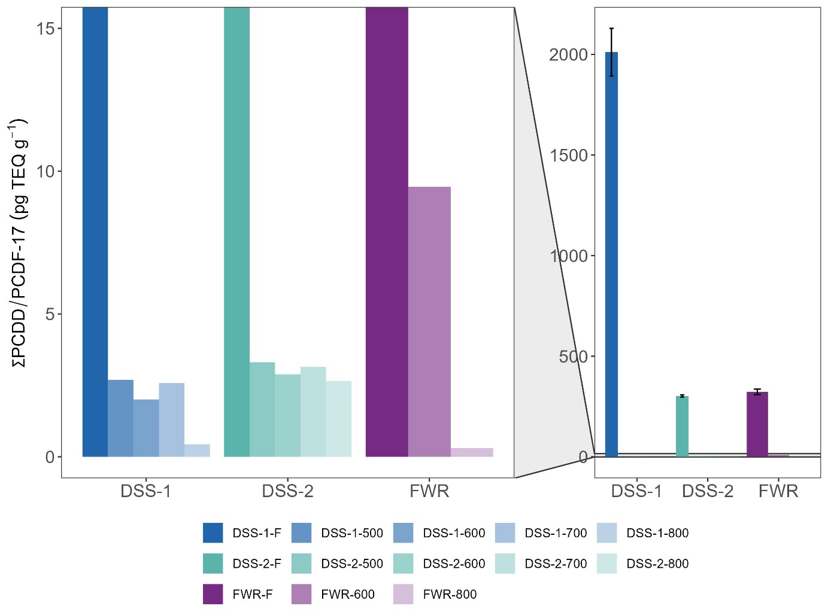

Figure 1 Total PCDD/F concentrations as toxic equivalents (ng TEQ kg-1) before and after pyrolysis treatment at increasing temperatures for the different feedstocks tested.

### PCBs in biochars

Concentrations of ∑PCB-7 in the biochar samples ranged from <LOQ (DSS-1-600) to 1.7 µg kg-1 (DSS-1-500) and were thus 1-2 orders of magnitude lower than in the original feedstocks (details on removal efficiency in Section 1.1, Table 4). All biochar samples were below the European Biochar threshold for premium quality biochar for sum TEQ PCDD/F of <20 ng kg-1 (EBC, 2022). There was no significant (p>0.05) linear relationship between reduction in PCB concentration and pyrolysis temperature. However, for DSS-1, the concentration of PCBs decreased from 500 to 700 to 800 ˚C (<LOQ at 600 ˚C). The other feedstocks (DSS-2 and LSS) were within the same order of magnitude for all temperatures.

Pyrolysis reduced the variety of PCB congeners – the biochar samples contained 14-100% (R: congeners) fewer congeners (mean 59 ± 25%, R: congeners_avg) than their feedstock materials (Figure S.X, haven’t made yet). The most persistent PCBs toward thermal degradation was PCB153 (6 Cl atoms), which was found in 90% of the biochars at all temperatures. PCB180 (7 Cl atoms) was degraded at all temperatures. Thus, there was no trend between the degree of chlorination and resistance towards thermal degradation that could be expected based on the literature (ref. Ecke).

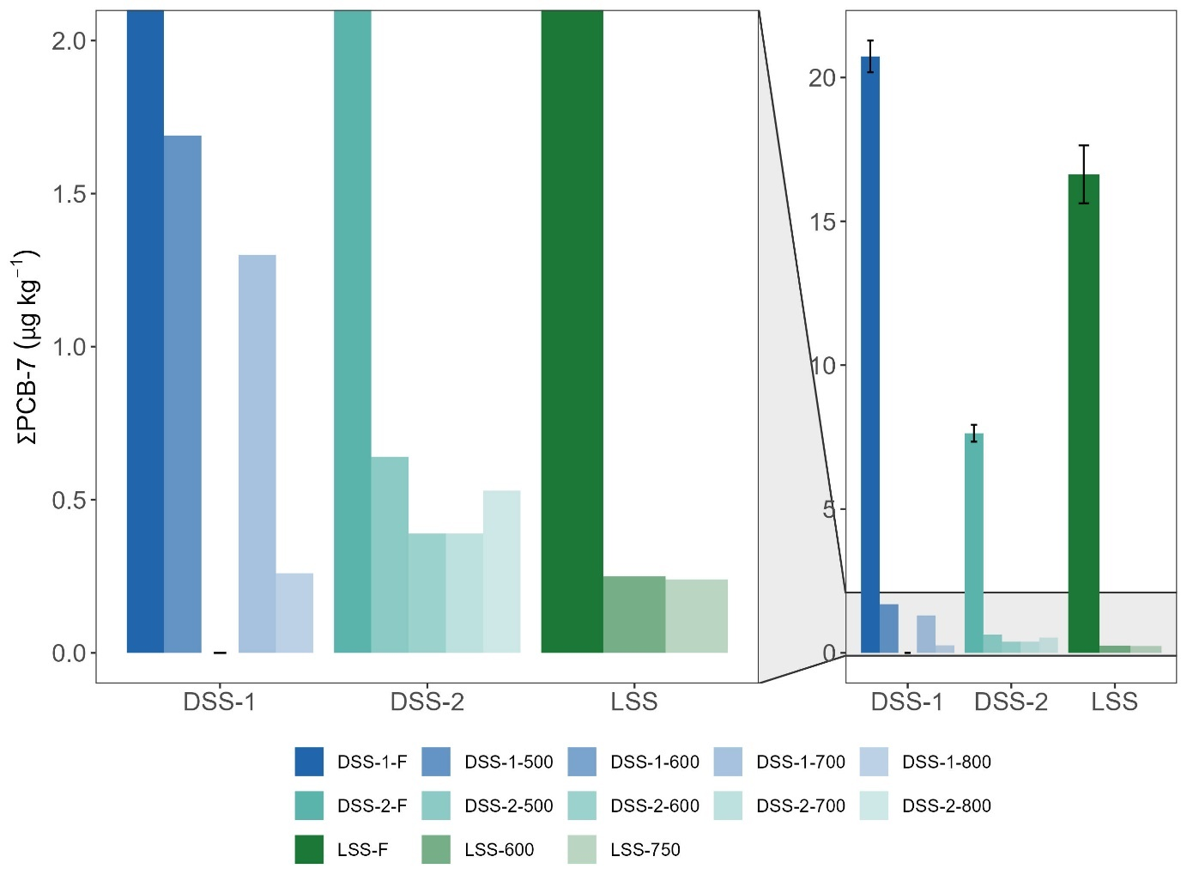

Figure 2 Total PCB-7 concentrations (µg kg-1) before and after pyrolysis treatment at increasing temperatures for the different feedstocks tested.

### PAHs in biochars

Only seven samples were below the European Biochar Certificate (EBC) limit for EBC-Agro, AgroOrganic and FeedPlus is <6 mg kg-1 for ∑16 EPA PAH (EBC, 2022): DSS-1-800, DSS-2-700, GW-600, LSS-600, LSS-750, WT-500, and WT-800. 18 of 23 biochar samples were below the ∑8 EFSA PAH limit of 1 mg kg-1 that applies to all biochar product types except for EBC-BasicMaterials which has a limit of 4 mg kg-1.

**Sewage sludge and food waste reject biochars.** The concentration of ∑PAH-16 in the sewage sludge biochars (SS-BCs) ranged from 0.38-37 mg kg-1 (Figure 3, Table S.X). The distribution of PAHs in the SS-BCs was similar for the four SSFs and mainly dominated by Nap (36-72%) and Phen (10-27%).

**Wood-based biochars.** The highest PAH-16 concentrations overall were found for waste timber (WT) where WT-600 contained 118 ± 5 mg kg-1 ∑PAH-16. %). This is well above the EBC limit value for EBCAgro, biochar certified for use in agriculture, of 6 mg kg-1 (EBC, 2022). The highest PAH-concentration in garden waste (GW) was found for GW-600 (14 ± 1 mg g-1). The distribution of PAHs in WT and GW was similar and mainly dominated by Flt (34 and 25%), Phen (10 and 28%), Pyr (22 and 17 %) (Figure S.X).

**Food waste reject biochar.** PAH-16 in FWR was 0.39 ± 0.01 µg g-1 (0.02 ± 0.1 µg TE g-1). The distribution of PAHs in FWR (Figure S.X) was dominated by Phen, Pyr and Flt (27, 19, and 17%, respectively), similar to the SSFs and WBFs.

Sørmo et al. (2020) reported a PAH-16 concentration of 14 ± 5 mg kg-1 for waste timber pyrolyzed at 600 ˚C in a medium-scale Pyreg 500 unit. Mean ∑PAH-16 concentration for all temperatures and feedstocks was 16±24 mg kg-1 and median was 7 mg kg-1 for…

The total concentration of PAHs and PCDD/Fs in biochar may not accurately reflect their bioavailability, as their high hydrophobicity renders them non-leachable. PAHs are known to bond via π-π interactions with aromatic rings in the condensed, aromatic rings of the biochar matrix, thereby enhancing their sorption onto the biochar surface (Hale et al., 2012). Similarly, the hydrophobic effects also apply to PCDD/Fs and PCBs.

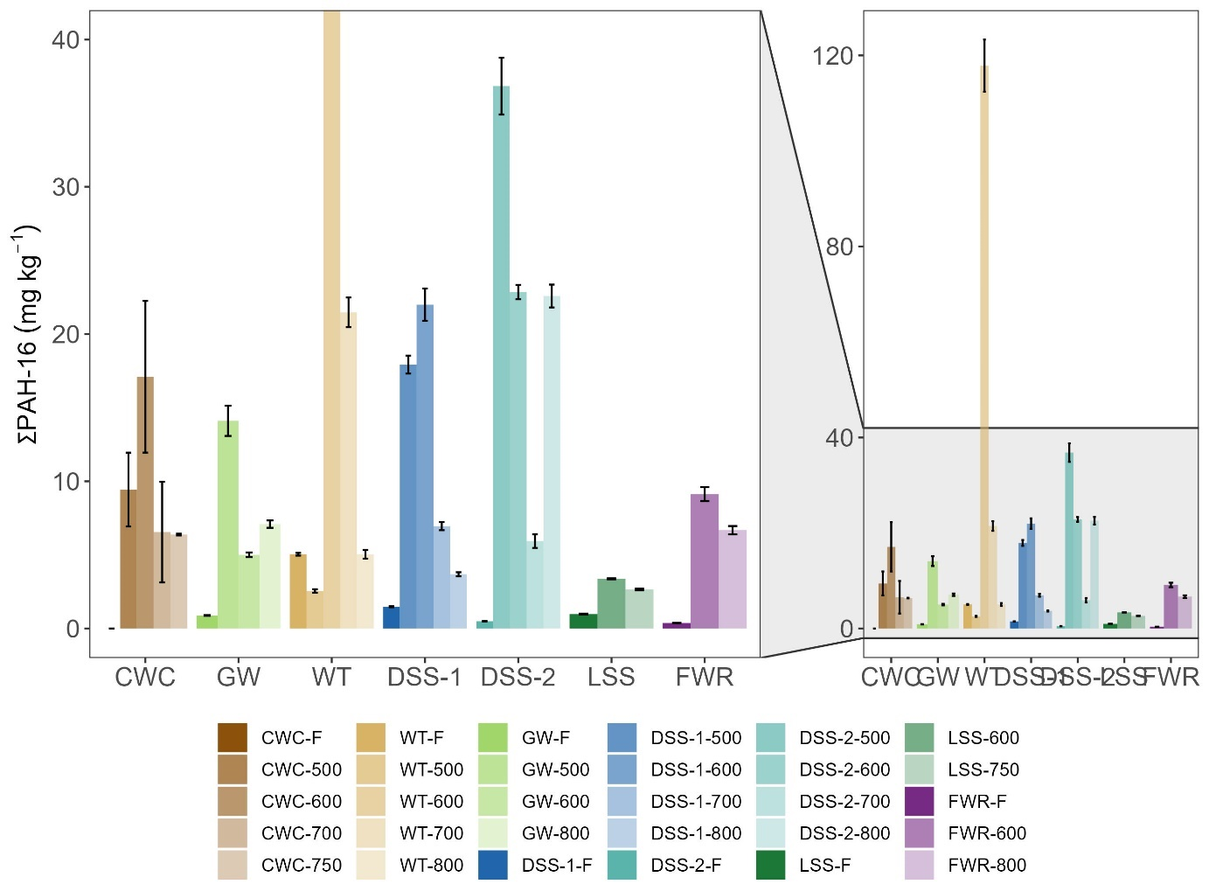

Figure 3 Total PAH-16 concentrations (mg kg-1) before and after pyrolysis treatment at increasing temperatures for the different feedstocks tested.

Table 3 Concentration of PAHs and PCDD/Fs in feedstock (F) and biochars at different temperatures, and respective EBC limit values.

|  |  |  |  |  |  |  |  |  |  |  |  |
| --- | --- | --- | --- | --- | --- | --- | --- | --- | --- | --- | --- |
| **PAHs (mg/kg)** | | | | | | **PCDD/F (ng/kg)** | | | **PCBs (µg/kg)** | | |
|  | **Temp.** | **∑16 EPA PAH** | **∑16 EPA PAH EBC limit** | **∑8 EFSA PAH** | **∑8 EFSA PAH EBC limit** | **∑17 PCDD/F (TEQ)** | **∑PCDD/F EBC limit** | **∑17 PCDD/F** | **∑7 PCB** | **∑PCB EBC limit** | **∑6 PCB EBC limit** |
| DSS-1 | F | 1.48 ± 0.03 | 6 mg/kg DM  for all EBC  products | 0.52 ± 0.01 | 1 mg/kg DM  (4 mg/kg DM for EBC-BasicMaterials) | 8.3 ± 0.4 | 20 ng/kg I-TEQ OMS | 2011 ± 118 | 21 | 200 µg/kg DM | 10 µg TEQ/kg DM |
| 500 | 18 ± 1 | 3.1 ± 0.09 | n.d. | 2.69 | 1.7 |
| 600 | 22 ± 1 | 1.73 ± 0.07 | n.d. | 2.01 | <LOQ |
| 700 | 7 ± 0.3 | 0.25 ± 0.01 | n.d. | 2.58 | 1.3 |
| 800 | 3.7 ± 0.1 | 0.14 ± 0.01 | n.d. | 0.44 | 0.3 |
| DSS-2 | F | 0.5 ± 0.02 | 0.148 ± 0.004 | 1.78 ± 0.04 | 302 ± 6 | 7.6 ± 0.3 |
| 500 | 37 ± 2 | 2.54 ± 0.08 | 0.03 | 3.31 | 0.6 |
| 600 | 22.9 ± 0.5 | 0.83 ± 0.01 | 0.02 | 2.89 | 0.4 |
| 700 | 5.9 ± 0.5 | 0.17 ± 0.01 | 0.03 | 3.15 | 0.4 |
| 800 | 23 ± 1 | 1.02 ± 0.05 | 0.03 | 2.66 | 0.5 |
| FWR | F | 0.38 ± 0.01 | 0.08 ± 0.004 | 1.18 ± 0.05 | 323 ± 14 | 9.2 ± 0.4 |
| 600 | 9.1 ± 0.5 | 0.22 ± 0.01 | 0.1 | 9.5 |  |
| 800 | 6.7 ± 0.3 | 0.2 ± 0.01 | 0.003 | 0.3 |  |
| LSS | F | 0.98 ± 0.03 | 0.39 ± 0.01 | 3 ± 0.1 | 589 ± 29 | 17 ± 1 |
| 600 | 3.38 ± 0.04 | 0.15 ± 0.01 | n.d. | n.d. | 0.3 |
| 750 | 2.7 ± 0.1 | 0.13 ± 0.01 | n.d. | n.d. | 0.2 |
| WT | F | 5 ± 0.1 | 1.08 ± 0.02 |  |  |  |  |  |  |
| 500 | 2.5 ± 0.1 | 0.16 ± 0.01 |  |  |  |  |  |  |
| 600 | 118 ± 5 | 7.46 ± 0.22 |  |  |  |  |  |  |
| 700 | 21 ± 1 | 0.45 ± 0.01 |  |  |  |  |  |  |
| 800 | 5 ± 0.3 | 0.13 ± 0.01 |  |  |  |  |  |  |
| GW | F | 0.89 ± 0.02 | 0.141 ± 0.005 |  |  |  |  |  |  |
| 500 | 14 ± 1 | 0.54 ± 0.02 |  |  |  |  |  |  |
| 600 | 5 ± 0.2 | 0.31 ± 0.01 |  |  |  |  |  |  |
| 800 | 7.1 ± 0.3 | 0.25 ± 0.01 |  |  |  |  |  |  |
| CWC | F | <LOQ | <LOQ |  |  |  |  |  |  |
| 500 | 9.4 ± 2.5 | 0.39 ± 0.08 |  |  |  |  |  |  |
| 600 | 17 ± 5 | 0.56 ± 0.19 |  |  |  |  |  |  |
| 700 | 6.6 ± 3.4 | 0.23 ± 0.09 |  |  |  |  |  |  |
| 750 | 6.4 ± 0.1 | 0.26 ± 0.02 |  |  |  |  |  |  |

## 

## Removal efficiencies

Removal efficiencies (RE) for ∑PCB-7 and ∑PCDD/PCDF-17 were >99.9% across all pyrolysis temperatures and feedstocks (Table 4). Thus, a pyrolysis temperature of 500 ˚C is likely sufficient to remove nearly 100% of PCBs and dioxins in sewage sludge feedstocks. Note that RE (Eq. 1) is corrected for biochar yield to account for mass reduction (yields in Table S.X). Researcher reported removal efficiency was reported to increase with increasing pyrolysis temperature, with the highest removal efficiency of >97% for PCBs observed at 700 degrees C (Moško et al., 2021). The authors noted that the removal efficiency was significantly influenced by the pyrolysis temperature and the molecular structure of the PCBs (Moško et al., 2021). In parallel studies, removal efficiencies of >99.5% for organophosphate flame retardants (∑OPFRs) in digested and lime stabilized sewage sludge pyrolyzed at 500-600 ˚C (Castro et al., 2023) and per- and polyfluoroalkyl substances (∑PFAS) of >98.27% for DSS-1, DSS-2, FWR, and LSS 500-800 ˚C (Sørmo et al., n.d.).

Table 4. Removal efficiency % (RE) of PCB-7 and PCDD/PCDF-17 in TEQ by pyrolysis of waste feedstocks at temperatures 500-800 °C normalized for yield biochar.

|  |  |  |  |
| --- | --- | --- | --- |
| **Feedstock** | **Pyr. temp. (˚C)** | **% RE** | |
| **∑PCB-7** | **∑PCDD/PCDF-17 (TEQ)** |
| DSS-1 | 500 | 99.97 | 99.99 |
| 600 | 99.95 | 99.99 |
| 700 | 99.97 | 99.99 |
| 800 | 99.95 | 99.99 |
| DSS-2 | 500 | 99.94 | 99.96 |
| 600 | 99.93 | 99.95 |
| 700 | 99.94 | 99.96 |
| 800 | 99.94 | 99.96 |
| FWR | 600 | n.d. | 99.94 |
| 800 | n.d. | 99.96 |
| LSS | 600 | 99.97 | n.d. |
| 750 | 99.97 | n.d. |

n.d. = pollutant not determined in biochar sample.

## Emission factors

Organic pollutant emission concentrations (EC), emission factors (EF), and distribution of pollutants between the particle and gas phase for each feedstock and treatment temperature are presented in Table 5.

### Emission factors dioxins

EFs for dioxins ranged from <LOQ to 0.45 µg TEQ tonne-1 and emission concentrations (EC) ranged from <LOQ to 41 pg m-3. Dioxins were primarily detected in the particle phase—77-100% of the total dioxins in the exhaust were associated with particles. This trend is expected for such hydrophobic compounds.

Emission concentrations of TCDD/Fs were 2-3 orders of magnitude lower than the EU emission standard (0.1 ng I-TEQ Nm−3) (Paradiz & Dilara, 2003) and four to five orders of magnitude lower than that observed from a Dutch municipal solid waste incineration plant (53 ng TEQ Nm-3 (Matthijsen et al., 1991).

### Emission factors PAHs

EFs for PAH-16 ranged from 4.7 to 30699 mg tonne-1 (Table 5). Sørmo pyreg-700 emission factor for WT-600: 20 ± 0.2 mg tonne-1 was similar to EF in this study was 11 mg tonne-1 (Sørmo et al., 2020). Emission concentration WT-600-Pyreg: 0.18 ± 0.03 µg m-3 versus 0.27 µg m-3 in the present study. The gas phase fraction was 43 ± 22% compared to 100% gaseous in this study. Clean wood was significantly higher EF than WT. satisfy premium or basic European Biochar Certificate criteria? PAHs were primarily detected in the gas phase—70-100% of the total PAHs in the exhaust were emitted as gas. In the gas phase, on average, 0.1% PAHs were carcinogenic, whereas 31% were carcinogenic in the particle phase. This means that the carcinogenic PAHs that consist of more rings, associate with particles because they are heavier.

Only two biochar samples (CWC-700 = 137 µg m-3 and DSS-2-500 = 421 µg m-3) had emission concentrations above the Dutch air regulations for asphalt mixing plants of 0.05 mg ∑16 PAH Nm-3 (Rijkswaterstaat, 2023).

Table 5 Emission concentrations (EC) and emission factors (EF) of PAH-16 and PCDD/F-17 and the respective toxic equivalents (TEQ) detected in flue gas from the pyrolysis of sewage sludge (DSS-1, DSS-2, LSS), wood-based feedstocks (WT, GW, and CWC) and reject (FWR) pyrolyzed at the temperatures specified, along with the relative fractions of ∑PAH-16 and ∑PCDD/F-17 found in the gaseous and particle-based fractions (%). The values are normalized to per kg biochar produced.

|  |  |  |  |  |  |  |  |  |  |  |  |  |  |  |  |  |  |  |  |  |
| --- | --- | --- | --- | --- | --- | --- | --- | --- | --- | --- | --- | --- | --- | --- | --- | --- | --- | --- | --- | --- |
| ***PAH-16*** | | | | | | | | | | | | | | | | | | | | |
|  | **DSS-1** | | | **DSS-2** | | | | **FWR** | | **LSS** | | **WT** | | | | **CWC** | | | **GW** | |
|  | **500** | **600** | **700** | **500** | **600** | **700** | **800** | **600** | **800** | **600** | **750** | **500** | **600** | **700** | **800** | **500** | **600** | **700** | **500** | **800** |
| **EC (µg m-3)** | 1.7 | 3.2 | 1.6 | 421 | 21 | 2.4 | 5.1 | 2.3 | 1.4 | 2 | 6 | 1.4 | 0.27 | 0.41 | 2.0 | 0.31 | 0.22 | 137 | 0.27 | 0.41 |
| **EC TEQ (µg m-3)** | 13 | 32 | 11 | 5288 | 1221 | 58 | 164 | 100 | 78 | 42 | 1738 | 0.01 | 0.0004 | 0.0005 | 0.010 | 203 | 69 | 30699 | 11 | 26 |
| **EF (mg tonne-1)** | 0.0022 | 0.0069 | 0.0026 | 3.7 | 0.0741 | 0.0060 | 0.029 | 0.0031 | 0.010 | 0.0095 | 0.022 | 78 | 11 | 26 | 42 | 0.00032 | 0.00023 | 1.9 | 0.00040 | 0.00049 |
| **EF TEQ (mg tonne-1)** | 0.01 | 0.03 | 0.01 | 5.3 | 1.2 | 0.06 | 0.16 | 0.10 | 0.08 | 0.04 | 1.7 | 0.08 | 0.01 | 0.03 | 0.04 | 0.20 | 0.07 | 31 | 0.01 | 0.03 |
| **Particles (%)** | 0 | 0 | 0 | 14 | 16 | 5 | 6 | 17 | 12 | 14 | 6 | 16 | 2 | 10 | 11 | 7 | 14 | 30 | 0 | 0 |
| **Gaseous (%)** | 100 | 100 | 100 | 86 | 84 | 95 | 94 | 83 | 88 | 86 | 94 | 84 | 98 | 90 | 89 | 93 | 86 | 70 | 100 | 100 |
| ***PCDD/F-17*** | | | | | | | | | | | |  |  |  |  |  |  |  |  |  |
|  | **DSS-1** | | | **DSS-2** | | | | **FWR** | | **LSS** | |  |  |  |  |  |  |  |  |  |
|  | **500** | **600** | **700** | **500** | **600** | **700** | **800** | **600** | **800** | **600** | **750** |  |  |  |  |  |  |  |  |  |
| **EC (pg m-3)** | <LOQ | <LOQ | <LOQ | 41 | 13 | 3.1 | 38 | <LOQ | 16 | 1.3 | 21 |  |  |  |  |  |  |  |
| **EC TEQ (pg m-3)** | <LOQ | <LOQ | <LOQ | 2.7 | 0.6 | 0.15 | 2.2 | <LOQ | 1.6 | 0.10 | 1.5 |  | |  |  |  |  |  |  |  |
| **EF (µg tonne-1)** | <LOQ | <LOQ | <LOQ | 0.52 | 0.75 | 0.08 | 1.2 | <LOQ | 0.90 | 0.03 | 6.2 |  | |  |  |  |  |  |  |  |
| **EF TEQ (µg tonne-1)** | <LOQ | <LOQ | <LOQ | 0.03 | 0.04 | 0.004 | 0.07 | <LOQ | 0.09 | 0.002 | 0.45 |  | |  |  |  |  |  |  |  |
| **Particles (%)** | <LOQ | <LOQ | <LOQ | 100 | 100 | 100 | 100 | <LOQ | 77 | 100 | 86 |  | |  |  |  |  |  |  |  |
| **Gaseous (%)** | <LOQ | <LOQ | <LOQ | 0 | 0 | 0 | 0 | <LOQ | 23 | 0 | 14 |  | |  |  |  |  |  |  |  |

## Distribution of pollutants in pyrolysis products

Table 6 shows how PAHs and PCDD/Fs are distributed between the different pyrolysis products at different temperatures, a mass balance of these pollutants, and from here a percent deviation between the total PCDD/F and PAH concentration in the feedstock and the summed concentration in the pyrolysis products as an estimation of PAH and PCDD/F formation/degradation. Note that the total concentrations in Table 6 are different from those reported for the remaining results because they have been normalized for yield of each pyrolysis product in order conduct a representative mass balance. Measured concentrations are provided in Tables S.X,Y,Z.

### PAHs

Table 6 shows how ∑PAH-16 are distributed between the different pyrolysis products for wood chips (CWC) and digested sewage sludge 1 (DSS-1) at different temperatures. For CWC and DSS-1, >98% of ∑PAH-16 end up in the pyrolysis oil except for CWC-700 on which 63% of the PAHs are in the oil and 37% are emitted in the exhaust. Measured PAH-16 concentrations in the pyrolysis oil ranged from 2.6-8.3 g kg-1 from DSS-1-870 and CWC-700, respectively (Table S.(5 so far).) and is thus regarded as hazardous waste. For the other products, less than 0.6% is emitted as exhaust. 0.14-1.33 % PAHs end up in the biochar. Since the PAH-content in the feedstocks were low and even below detection limits (<LOQ for CWC and 0.09 mg kg-1 for DSS-1), this shows that PAHs are formed during pyrolysis, in accordance with what is expected during incomplete combustion processes (Buss et al., 2022). The Biogreen unit is designed to achieve a rapid separation of pyrolysis gas and biochar to avoid recondensation of compounds volatilized from the solid matrix, such as PAHs. Volatilized PAHs thus exit the pyrolysis reactor to be precipitated in the pyrolysis oil or emitted with the flue gas. Most of the PAHs partition into the oil rather than the flue gas because of the high affinity of hydrophobic PAH (high *K*OW) for the condensed oil fraction (Papari & Hawboldt, 2018). For all samples except DSS-1-700, ∑PAH-16 in biochar is below or equivalent to the EBC limit value for most biochar products (<6 mg kg-1) (EBC, 2022).

### PCDD/Fs

Table 6 shows how ∑PCDD/F-17 are DSS-1-600, DSS-2-600, and FWR-800 in both total concentration and TEQ. Based on total feedstock concentrations, 95-99% PCDD/F-17 partitions to the pyrolysis oil, 1-5% are in the biochar, and 0-0.04% are emitted in the exhaust. Measured PCDD/F-17 concentrations in the pyrolysis oil were as high as 1241 ng kg-1 for DSS-1-600 (50 ng TEQ kg-1) and 16 and 1.8 ng TEQ kg-1 for FWR-800 and DSS-1-600, respectively (Table S.X(5 so far).). High concentrations of PCDD/Fs along with PAHs on the g per kg magnitude, the pyrolysis oil is a hazardous byproduct. 71-87% less PCDD/Fs were detected in the oil, biochar, and exhaust together than the starting concentration in the feedstock Table 6. Despite the expected large measurement errors in the mass balance, there are no signs that dioxins are formed during pyrolysis, and it is likely that some dioxins may have been decomposed or dechlorinated. However, the same deviation calculation when using TEQ-converted concentrations, yields an opposite trend. PCDD/F-17 concentration in TEQ increases for two of the three feedstocks tested. This may indicate that some PCDD/Fs becomes more toxic transformation products during pyrolysis. There was no statistically significant relationship (p>0.05) between chlorine content in the feedstocks and distribution of PCDD/Fs in the pyrolysis products (Cl-content in feedstocks provided in Table S.X.).

### PCBs

A total mass balance was not conducted for PCBs because PCBs was not measured in the exhaust. PCB-7-concentration in the pyrolysis oil was 0.8, 3.2, and 3.5 µg kg-1 for DSS-2-600, LSS-600, and DSS-1-600, respectively.

Table 6 Distribution of ∑PAH-16 and ∑PCDD/F-17 in biochar, pyrolysis oil, and exhaust (particles and gas) in total concentration for PAHs and both total and TEQ for PCDD/Fs and percent distribution. The distribution is normalized to the amount of feedstock used to produce the corresponding product fractions and normalized for yield of each pyrolysis product. The mass balance deviation is the difference in percent between the total PCDD/F-concentration in the feedstock and the summed concentration in the pyrolysis products to estimate PAH and PCDD/F formation/degradation.

|  |  |  |  |  |  |  |  |  |  |  |
| --- | --- | --- | --- | --- | --- | --- | --- | --- | --- | --- |
| **PAH-16** |  | **∑PAH-16 concentration** | | | | | **% ∑PAH-16 distribution** | | | **Mass balance deviation** |
|  |  | **mg kg-1** | | | | | **%** | | | **Sum PAH-16** |
| **feedstock** | **Pyr. temp. ˚C** | **feedstock** | **biochar** | **exhaust** | **oil** | **total** | **biochar** | **exhaust** | **oil** | **Biochar + exhaust + oil** |
| CWC | 500 | <LOQ | 1.7 | 3.0 | 1191 | 1195 | 0.14 % | 0.25 % | 99.61 % | + 100% |
| 600 | 3.37 | 1.9 | 2627 | 2632 | 0.13 % | 0.07 % | 99.80 % |
| 700 | 1.3 | 1317 | 2204 | 3522 | 0.04 % | 37.39 % | 62.57 % |
| DSS-1 | 600 | 1.48 | 13 | 3.1 | 946 | 962 | 1.33 % | 0.32 % | 98.34 % | + 650% |
| 700 | 4.3 | 1.2 | 801 | 807 | 0.53 % | 0.14 % | 99.32 % | + 545% |
| **PCDD/F** |  | **∑PCDD/F-17**  **concentration** | | | | | **% ∑PCDD/F-17**  **distribution** | | | **Mass balance deviation** |
|  |  | **µg TEQ kg-1** | | | | | **%** | | | **TEQ PCDD/F** |
| **feedstock** | **Pyr. temp. ˚C** | **feedstock** | **biochar** | **exhaust** | **oil** | **total** | **biochar** | **exhaust** | **oil** | **Biochar + exhaust + oil** |
| DSS-1 | 600 | 8.3 | 0.005 | <LOQ | 10.99 | 11.00 | 0.43 % | 0.00 % | 99.57 % | + 33% |
| DSS-2 | 600 | 1.8 | 0.01 | 0.002 | 0.45 | 0.46 | 4.03 % | 0.12 % | 95.86 % | - 26% |
| FWR | 800 | 1.2 | 0.001 | 0.01 | 3.53 | 3.54 | 0.10 % | 0.10 % | 99.79 % | + 300% |
|  |  | **µg kg-1** | | | | | **%** | | | **Sum PCDD/F** |
| **feedstock** | **Pyr. temp. ˚C** | **feedstock** | **biochar** | **exhaust** | **oil** | **total** | **biochar** | **exhaust** | **oil** | **Biochar + gas + oil** |
| DSS-1 | 600 | 2011 | 1.17 | <LOQ | 270.46 | 271.63 | 0.43 % | 0.00 % | 99.57 % | - 86% |
| DSS-2 | 600 | 302 | 1.24 | 0.04 | 29.61 | 30.89 | 4.03 % | 0.12 % | 95.86 % | - 90% |
| FWR | 800 | 323 | 0.10 | 0.10 | 98.74 | 98.95 | 0.10 % | 0.10 % | 99.79 % | - 69% |

# Conclusions

PCDD/Fs and PCBs are mostly eliminated from the biochars (>99.9% removal efficiencies). PAHs might accumulate in some biochars (differences between feedstocks and possibly temperatures), but the design of the unit can reduce their presence.

Pyrolysis condensates are toxic and potentially hazardous waste due to their high concentrations of PAHs, warrants proper safe handling. Possibly with high temp incineration as end of chain. Add if there is PCBs and PCDDs in oil.

Dioxin emissions are very low, despite having some feedstocks with relatively high Cl contents (awaiting data). PAH emissions are mostly particle-bound (70-100%), and total emission concentrations of ∑16 PAH were below the suggested industrial limit of 0.05 mg Nm-3 (Rijkswaterstaat, 2023). This suggests that flue gas cleaning is not needed.

Pyrolysis oil is heavily contaminated, most of the organic pollutants partition into this fraction. Thus, pyrolysis oil must be handled as hazardous waste.

Supporting Information

Supplementary data associated with this article can be found here x.

Acknowledgements

The authors acknowledge funding from the Research Council of Norway, mainly through the joint-industry sustainability (BIA-X) project “Valorization of Organic Waste” (VOW) (NFR 299070) whereof Lindum AS (stakeholder in sorbent application), the Norwegian Geotechnical Institute (research institute and project leader), and Scanship (technology supplier) played the key roles for generating the test material and data for this manuscript.

References

Buss, W. (2021). Pyrolysis solves the issue of organic contaminants in sewage sludge while retaining carbon—making the case for sewage sludge treatment via pyrolysis. *ACS Sustainable Chemistry & Engineering*, *9*(30), 10048–10053.

Buss, W., Hilber, I., Graham, M. C., & Mašek, O. (2022). Composition of PAHs in biochar and implications for biochar production. *ACS Sustainable Chemistry & Engineering*, *10*(20), 6755–6765.

Castro, G., Sørmo, E., Yu, G., Sait, S. T. L., González, S. V, Arp, H. P. H., & Asimakopoulos, A. G. (2023). Analysis, occurrence and removal efficiencies of organophosphate flame retardants (OPFRs) in sludge undergoing anaerobic digestion followed by diverse thermal treatments. *Science of The Total Environment*, *870*, 161856.

Castro-Jiménez, J., Deviller, G., Ghiani, M., Loos, R., Mariani, G., Skejo, H., Umlauf, G., Wollgast, J., Laugier, T., Héas-Moisan, K., Léauté, F., Munschy, C., Tixier, C., & Tronczyński, J. (2008). PCDD/F and PCB multi-media ambient concentrations, congener patterns and occurrence in a Mediterranean coastal lagoon (Etang de Thau, France). *Environmental Pollution*, *156*(1), 123–135. https://doi.org/10.1016/J.ENVPOL.2007.12.019

Chen, S.-J., Su, H.-B., Chang, J.-E., Lee, W.-J., Huang, K.-L., Hsieh, L.-T., Huang, Y.-C., Lin, W.-Y., & Lin, C.-C. (2007). Emissions of polycyclic aromatic hydrocarbons (PAHs) from the pyrolysis of scrap tires. *Atmospheric Environment*, *41*(6), 1209–1220.

Conesa, J. A., Font, R., Fullana, A., Martin-Gullon, I., Aracil, I., Gálvez, A., Moltó, J., & Gómez-Rico, M. F. (2009). Comparison between emissions from the pyrolysis and combustion of different wastes. *Journal of Analytical and Applied Pyrolysis*, *84*(1), 95–102.

Cornelissen, G., Amstaetter, K., Hauge, A., Schaanning, M., Beylich, B., S. Gunnarsson, J., D. Breedveld, G., M.P. Oen, A., & Eek, E. (2012). Large-Scale Field Study on Thin-Layer Capping of Marine PCDD/F-Contaminated Sediments in Grenlandfjords, Norway: Physicochemical Effects. *Environmental Science &amp; Technology*, *46*(21), 12030–12037. https://doi.org/10.1021/es302431u

EBC. (2022). European Biochar Certificate - Guidelines for a Sustainable Production of Biochar. *Carbon Standards International (CSI), Frick, Switzerland*, *10.2*.

Eljarrat, E., & Barceló, D. (2003). Priority lists for persistent organic pollutants and emerging contaminants based on their relative toxic potency in environmental samples. *TrAC Trends in Analytical Chemistry*, *22*(10), 655–665. https://doi.org/10.1016/S0165-9936(03)01001-X

Gabrielsen, G. W., & Henriksen, E. O. (1974). Persistent organic pollutants in Arctic animals in the Barents. *Memoirs of National Institute of Polar Research*, *54*, 349.

Greco, G., Videgain, M., Di Stasi, C., Pires, E., & Manyà, J. J. (2021). Importance of pyrolysis temperature and pressure in the concentration of polycyclic aromatic hydrocarbons in wood waste-derived biochars. *Journal of Analytical and Applied Pyrolysis*, *159*, 105337. https://doi.org/10.1016/J.JAAP.2021.105337

Hale, S. E., Lehmann, J., Rutherford, D., Zimmerman, A. R., Bachmann, R. T., Shitumbanuma, V., O’Toole, A., Sundqvist, K. L., Arp, H. P. H., & Cornelissen, G. (2012). Quantifying the total and bioavailable polycyclic aromatic hydrocarbons and dioxins in biochars. *Environmental Science & Technology*, *46*(5), 2830–2838.

Hilber, I., Mayer, P., Gouliarmou, V., Hale, S. E., Cornelissen, G., Schmidt, H. P., & Bucheli, T. D. (2017). Bioavailability and bioaccessibility of polycyclic aromatic hydrocarbons from (post-pyrolytically treated) biochars. *Chemosphere*, *174*, 700–707. https://doi.org/10.1016/J.CHEMOSPHERE.2017.02.014

Horii, Y., Ok, G., Ohura, T., & Kannan, K. (2008). Occurrence and profiles of chlorinated and brominated polycyclic aromatic hydrocarbons in waste incinerators. *Environmental Science & Technology*, *42*(6), 1904–1909.

Hu, Z., Nomura, N., Kong, H., Wijesekara, S., & Matsumura, M. (2007). Changes in Chlorinated Organic Pollutants and Heavy Metal Content of Sediments during Pyrolysis (7 pp). *Environmental Science and Pollution Research-International*, *14*, 12–18.

Huygens, D., Saveyn, H., Tonini, D., Eder, P., & Delgado Sancho, L. (2019). Technical proposals for selected new fertilising materials under the Fertilising Products Regulation (Regulation (EU) 2019/1009). *FeHPO CaHPO*, *4*.

Jia, S., Wang, Q., Li, L., Fang, X., Shi, Y., Xu, W., & Hu, J. (2014). Comparative study on PCDD/F pollution in soil from the Antarctic, Arctic and Tibetan Plateau. *Science of The Total Environment*, *497–498*, 353–359. https://doi.org/10.1016/J.SCITOTENV.2014.07.109

Kloss, S., Zehetner, F., Dellantonio, A., Hamid, R., Ottner, F., Liedtke, V., Schwanninger, M., Gerzabek, M. H., & Soja, G. (2012). Characterization of slow pyrolysis biochars: effects of feedstocks and pyrolysis temperature on biochar properties. *Journal of Environmental Quality*, *41*(4), 990–1000.

Kwon, H. O., & Choi, S. D. (2014). Polycyclic aromatic hydrocarbons (PAHs) in soils from a multi-industrial city, South Korea. *Science of The Total Environment*, *470–471*, 1494–1501. https://doi.org/10.1016/J.SCITOTENV.2013.08.031

Matthijsen, A., van Jaarsveld, J. A., & Sein, A. A. (1991). Evaluatie van de dioxine-emissies van de afvalverbrandingsinstallatie in Weurt. *RIVM Rapport 730501032*.

Moško, J., Pohořelý, M., Cajthaml, T., Jeremiáš, M., Robles-Aguilar, A. A., Skoblia, S., Beňo, Z., Innemanová, P., Linhartová, L., & Michalíková, K. (2021). Effect of pyrolysis temperature on removal of organic pollutants present in anaerobically stabilized sewage sludge. *Chemosphere*, *265*, 129082.

Nakajima, D., Nagame, S., Kuramochi, H., Sugita, K., Kageyama, S., Shiozaki, T., Takemura, T., Shiraishi, F., & Goto, S. (2007). Polycyclic aromatic hydrocarbon generation behavior in the process of carbonization of wood. *Bulletin of Environmental Contamination and Toxicology*, *79*, 221–225.

Olie, K., Vermeulen, P. L., & Hutzinger, O. (1977). Chlorodibenzo-p-dioxins and chlorodibenzofurans are trace components of fly ash and flue gas of some municipal incinerators in the Netherlands. *Chemosphere*, *6*(8), 455–459.

Papari, S., & Hawboldt, K. (2018). A review on condensing system for biomass pyrolysis process. *Fuel Processing Technology*, *180*, 1–13. https://doi.org/10.1016/J.FUPROC.2018.08.001

Paradiz, B., & Dilara, P. (2003). *Dioxin emissions in the candidate countries: Sources, emission inventories, reduction policies and measures*.

Paulsrud, B., Wien, A., & Nedland, K. T. (1997). *A survey of toxic organics in Norwegian sewage sludge compost and manure*.

Pereira, M. D. S., & Kuch, B. (2005). Heavy metals, PCDD/F and PCB in sewage sludge samples from two wastewater treatment facilities in Rio de Janeiro State, Brazil. *Chemosphere*, *60*(7), 844–853. https://doi.org/10.1016/J.CHEMOSPHERE.2005.01.079

Rijkswaterstaat. (2023, April). *Luchtvoorschriften voor asfaltmenginstallaties - Dutch Ministry of Infrastructure and Water Management*. https://www.infomil.nl/onderwerpen/lucht-water/lucht/activiteiten/artikel/#he2375fee-539c-40a3-b7b7-a2e792617cd1

Rogovska, N., Laird, D., Cruse, R. M., Trabue, S., & Heaton, E. (2012). Germination tests for assessing biochar quality. *Journal of Environmental Quality*, *41*(4), 1014–1022.

Sørmo, E., Castro, G., Hubert, M., Licul-Kucera, V., Quintanilla, M., Asimakopoulos, A. G., Cornelissen, G., & Arp, H. P. H. (n.d.). The Decomposition and Emission Factors of a Wide Range of Pfas in Diverse, Contaminated Organic Waste Fractions Undergoing Dry Pyrolysis. *Contaminated Organic Waste Fractions Undergoing Dry Pyrolysis*.

Sørmo, E., Silvani, L., Thune, G., Gerber, H., Schmidt, H. P., Smebye, A. B., & Cornelissen, G. (2020). Waste timber pyrolysis in a medium-scale unit: Emission budgets and biochar quality. *Science of the Total Environment*, *718*, 137335.

Stanmore, B. R. (2004). The formation of dioxins in combustion systems. *Combustion and Flame*, *136*(3), 398–427.

Stevens, J., Green, N. J. L., & Jones, K. C. (2001). Survey of PCDD/Fs and non-ortho PCBs in UK sewage sludges. *Chemosphere*, *44*(6), 1455–1462. https://doi.org/10.1016/S0045-6535(00)00474-4

Törnkvist, A., Glynn, A., Aune, M., Darnerud, P. O., & Ankarberg, E. H. (2011). PCDD/F, PCB, PBDE, HBCD and chlorinated pesticides in a Swedish market basket from 2005 – Levels and dietary intake estimations. *Chemosphere*, *83*(2), 193–199. https://doi.org/10.1016/J.CHEMOSPHERE.2010.12.042

Warenik-Bany, M., Maszewski, S., Mikolajczyk, S., & Piskorska-Pliszczynska, J. (2019). Impact of environmental pollution on PCDD/F and PCB bioaccumulation in game animals. *Environmental Pollution*, *255*, 113159. https://doi.org/10.1016/J.ENVPOL.2019.113159

Wilcke, W. (2000). Synopsis polycyclic aromatic hydrocarbons (PAHs) in soil—a review. *Journal of Plant Nutrition and Soil Science*, *163*(3), 229–248.